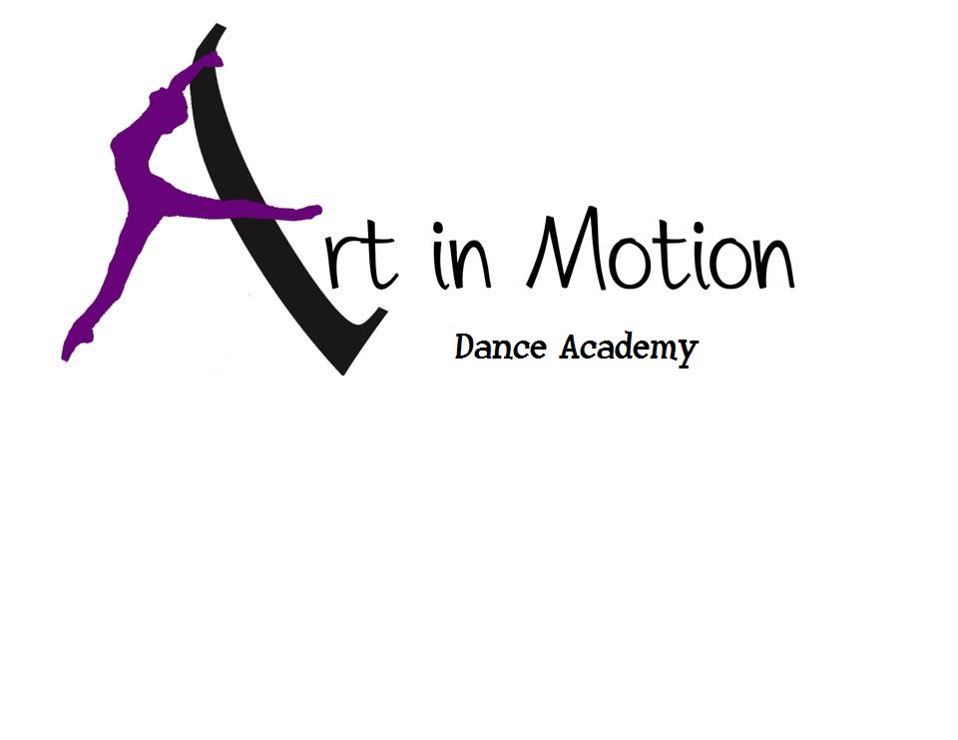
STUDENT’S NAME: ____________________________________________________________
PARENT’S NAME: _________________________________________________________________
PHONE: (HOME)__________________(CELL)__________________(OTHER)________________
STUDENT’S CELL/EMAIL: __________________________________________________________
STUDENTS DATE OF BIRTH:________________________________________________________
MAILING ADDRESS:______________________________________________________________
BILLING EMAIL:______________________________ CONTACT EMAIL:_____________________
EMERGENCY CONTACT NAME & PHONE:_____________________________________________
Signing below indicates that I have read the policies of Art in Motion Dance Academy and will abide by said policies. I, the undersigned, fully understand and agree that the owners/instructors of Art in Motion Dance Academy shall be free of any liability of claims arising by reason of any injury, illness, or any dance related activity with Art in Motion Dance Academy. Permission is hereby granted to transport my child to a doctor or hospital in case of illness or injury when unable to locate the parent/guardian or emergency name:
______________________________________________________________________________
(Signature of Parent/Guardian) Date: ___________________________
OFFICE USE ONLY
CLASS | Day | Time | Wait list
Registration fee $20 paid check # receipt # date:
Performance fee $35 paid check # receipt # date:

